How to complete the DOEPA Parish Financial Report
The DOEPA Parish Financial Report (the report) was designed to allow parishes a standard form for submission of annual financial information to the Diocese. This will allow easier consolidation, comparison, and analysis of financial information, so that the Diocesan Council and administration can make well-informed decisions concerning the ongoing function of the Diocese.
Though rumors have been spread that the Diocese is “planning to take our property or assets,” that is simply not true. The Hierarchical Authority wants to monitor the financial health of parishes in order to anticipate financial shortfalls and potential parish closures. Unfortunately, when a parish faces financial collapse, the repercussions will also be felt at the Diocesan level.
Parishes do not have to change their internal bookkeeping or accounting methods, but they will have to consolidate that information onto this report for submission to the Diocese. The following instructions will assist in the completion of the report.
Excel Format
The report is available in Excel format to allow for easier creation and electronic submission. It is automated so that sums and balances will be calculated for you. A .pdf file is also available for printing if manual processing is desired. In the notes below auto calculated fields will be identified and the means for calculation will be stated.
- Protected Cells
  - The report is protected so that the form itself cannot be changed, only the information in the applicable cells.
- Navigation
  - To move from cell to cell use the Enter key or the right arrow key
Use of this guide
This guide should be used for reference purposes while completing the DOEPA Parish Financial Report. If you are unsure of where an item should be entered feel free to contact the Diocesan Treasurer or a member of the Diocesan Finance Committee.
Filling out the form
Generally speaking the entries on the form are self-explanatory, but the following instructions may be helpful to those who need guidance concerning some aspects of parish finances.

General Information section
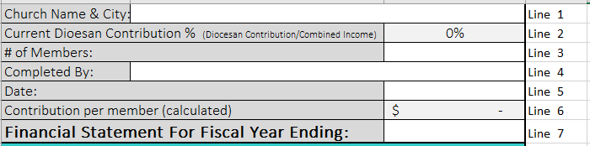
- Line 1 - Church Name & City:
  - Enter the name of your church and the city in which it’s located
- Line 2 - Current Diocesan Contribution % (Diocesan & OCA Contribution/Combined Income)
  - For Excel – this is auto calculated for your information
  - For manual processing
    - Divide Line 21 (Diocesan Contribution) by Line 65 (COMBINED INCOME) to determine the percentage of parish income that is contributed to the Diocese (which will fulfill the OCA obligation)
  - NOTE: This figure shows the actual calculated percentage that your parish is giving to the Diocese; it should be checked against your parish’s commitment to the Diocese to see if you are fulfilling your obligation to the Diocese based on Giving Levels.
- Line 3 - # of Members:
  - Enter the number of adult parishioners (over 18 years old)
- Line 4 - Completed By:
  - Enter the name of the person completing this form on behalf of the parish
- Line 5 - Date:
  - Enter the date the form was completed
- Line 6 - Contribution per member (calculated)
  - For Excel – this is auto calculated for your information
  - For manual processing
    - Line 15 (Collections, Candles, Assessments…) is divided by the Line 3 (# of Members) to determine the average amount contributed per member
- Line 7 - Financial Statement For Fiscal Year Ending:
  - Enter the year upon which this information is based; there are several methods you may choose:
    - Last completed calendar year
      - E.g.,, Enter 1/1/20xx – 12/31/20xx
    - Last completed fiscal year
      - E.g., Enter 10/1/20xx – 10/1/20xy
    - Next year’s projected budget
      - Either calendar or fiscal
        - E.g., Calendar; enter 1/1/20xx - 12/31/20xx
        - E.g., Fiscal; enter fiscal start date for this year to fiscal end date next year
    - The last completed 12-month period
      - E.g., 9/1/20xx – 9/1/20xy

Cash at Beginning of Year
This section records the assets that the parish has at the beginning of the recording period.
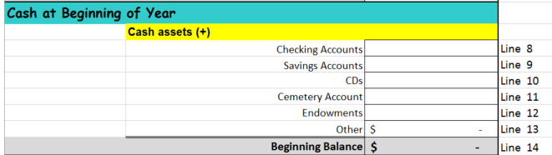
Cash Assets
- Line 8 - Checking Accounts
  - Enter the total amount in all parish checking accounts at the beginning of the reporting period
- Line 9 - Savings Accounts
  - Enter the total amount in all parish savings accounts at the beginning of the reporting period
- Line 10 - CDs
  - Enter the current value of all Certificates of Deposit owned by the church at the beginning of the reporting period
- Line 11 - Cemetery Account
  - If the parish has a cemetery and maintains separate accounts for the cemetery then enter the amount in all cemetery accounts at the beginning of the reporting period
NOTE: if the cemetery is incorporated as its own corporate entity, then income or expenses associated with the cemetery should not show in the parish’s financial records. The cemetery corporation and the parish must maintain separation of assets and be aware of the consequences of co-mingling of funds.
- Line 12 – Endowments
  - If there are any restricted endowments in accounts separate from your checking or savings account enter the total amount at the beginning of the reporting period here
- Line 13 – Other
  - If the parish is holding non-cash assets, such as stocks, savings bonds, or other liquid assets then enter the total amount at the beginning of the reporting period here
    - Do not enter the value of real estate, autos, personal property, etc
- Line 14 - Beginning Balance
  - For Excel – this is auto calculated
  - For manual processing
    - Add Lines 8 through 13 and enter the sum here
Cash Flow from Operating Activities section
This section will record the operating income and expenses for the parish. Ultimately it will show the net profit (or loss) of the parish in a particular year.
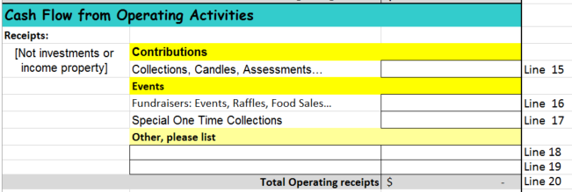 Receipts:
This section will record any income generated for operational expenses. It does not include income from investment properties or financial instruments, such as stocks bonds, etc. those items will be accounted for in other areas of the form.
Contributions
- Line 15 - Collections, Candles, Assessments…
  - Enter all income from normally recurring sources, such as weekly collections, candles, Prosphora, donations boxes, etc.
  - Include money collected on a regular basis for normal operational expenses, such as building funds, utilities funds, etc.
  - Do not include collections for charities that will simply “pass though” the parish accounting. E.g., - a collection is taken for a local food bank and all the money collected goes directly to the food bank
Events
- Line 16 - Fundraisers: Events, Raffles, Food Sales…
  - Enter the total gross amount of money collected from all fundraising activities such as food festivals, food sales, and other events that are above and beyond typical member contributions (Note: the expenses for these events will be recorded below, consequently this line should reflect the gross (not net) income
- Line 17 - Special One Time Collections
  - Enter the amount collected above and beyond normal offerings which will be used for operational expenses
    - E.g., – a special collection is taken to pay for an excessively high fuel bill, or an unplanned repair
  - Do not include “pass through” collections to charities
Other, please list
  - Line 18 - enter a brief description and a dollar amount for any income not otherwise recorded, E.g., a bequest, an unexpected contribution, or other one-time gift
  - Line 19 – same as Line 18 (if needed)
Line 20 - Total Operating receipts
- For Excel – this is auto calculated
- For manual processing –
  - Enter the sum of Lines 15 through 19

Disbursements:
This section records the expenses of the parish, except those associated with income property or financial
General Operating and Administrative Expenses
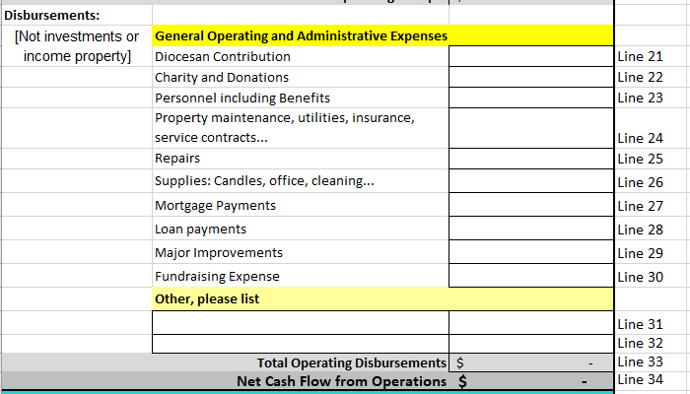
- Line 21 - Diocesan Contribution
  - Enter the amount paid to the Diocese for Diocesan and OCA support
    - Amount should be in accordance with current Diocesan and OCA guidelines, currently 10% of operating income.
- Line 22 - Charity and Donations
  - Enter the amount paid from parish funds to charities or donated to other causes
    - E.g., – a donation for the 100th anniversary of a parish, or a gift to another non-profit organization, such as OCMC, IOCC, a soup kitchen, or others
  - Do not include “pass through” collections to charities, only those disbursements coming from the parish funds
- Line 23 - Personnel including Benefits
  - Enter the total amount spent on Rector compensation, benefits, and allowances, as well as any disbursements to other clergy, choir directors, administrative assistance, etc.
- Line 24 - Property maintenance, utilities, insurance, service contracts...
  - Enter the total amount spent maintaining the church property, including all utilities, telephone, service contracts, landscaping maintenance costs, etc.
    - NOTE: if the parish house, and any associated expenses (such as maintenance, utilities, etc.) is considered part of the Rector’s compensation package include the amounts spent on the parish house in either Line 23 or Line 24, but not in both
- Line 25 – Repairs
  - Enter the total amount spent on repairs of the church property or equipment
- Line 26 - Supplies: Candles, office, cleaning...
  - Enter the total amount spent on candles, office supplies, furniture, office equipment maintenance agreement costs, cleaning services or supplies, liturgical supplies, etc.
- Line 27 - Mortgage Payments
  - Enter the amount paid in mortgage payments for the church, parish hall, and/or rectory
    - Include principal and interest
- Line 28 - Loan payments
  - Enter the amount paid in loan payments other than mortgages
- Line 29 - Major Improvements
  - Enter the amount spent on major improvements E.g., building additions, remodels, new construction
- Line 30 - Fundraising Expense
  - Enter the total of all expenses for fundraisers
- Other, please list
  - Line 31 - enter a brief description and a dollar amount for any expense not otherwise recorded
  - Line 32 - same as Line 31 (if needed)
- Line 33 - Total Operating Disbursements
  - For Excel – this is auto calculated
  - For manual processing
    - Add lines 21 through 32 and enter the sum here
- Line 34 - Net Cash Flow from Operations
  - For Excel – this is auto calculated
  - For manual processing
    - Subtract Line 33 (Total Operating Disbursements) from Line 20 (Total Operating receipts) and enter the difference here
  - NOTE: this amount is an indicator of the financial health of your parish.

Cash Flow from Income Property section
This section records any income as a result of property investments. Only those expenses specifically related to the use of property for other than worship or regular fellowship should be included here. (If the parish house is occupied by the Rector then the expenses associated with it should reflect either in Rector’s compensation or in other Operational Expense categories.) Parishes without income properties will leave this section blank.
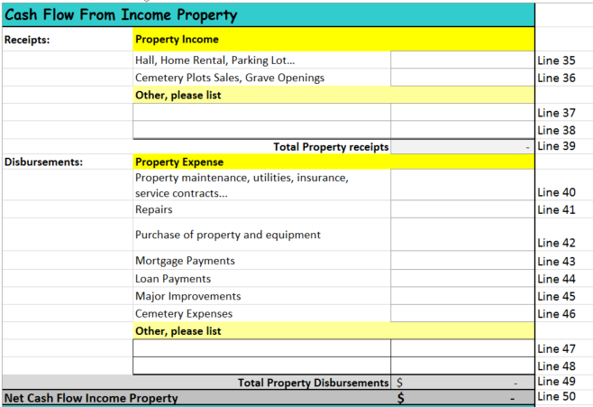
Receipts: Property Income
- Line 35 - Hall, Home Rental, Parking Lot…
  - Enter all income generated from the rental of the hall, parish house, parking lot, or any other real estate belonging to the parish
    - E.g., - Renting the hall as a polling place or for wedding receptions
- Line 36 - Cemetery Plots Sales, Grave Openings
  - Enter all income associated with the sale of cemetery plots, or grave openings, or other income that may be generated as a result of burials
  - Not applicable if the cemetery is run as a separate corporation
- Other, please list
  - Line 37 - enter a brief description and a dollar amount for any property income not otherwise recorded
  - Line 38 - same as Line 37 (if needed)
- Line 39 - Total Property receipts
  - For Excel – this is auto calculated
  - For manual processing
    - Add lines 35 through 38 and enter the sum here
Disbursements: Property Expense
- Line 40 - Property maintenance, utilities, insurance, service contracts...
  - Enter all expenses associated with the maintenance of income properties
  - Include any taxes paid on income property
  - Do not enter expenses associated with the Cemetery, since those will be separately recorded on Line 46
- Line 41 – Repairs
  - Enter the total amount spend on repairs of income property
- Line 42 - Purchase of property and equipment
  - Enter all expenses related to the purchase of income property or equipment to be used exclusively for income property
- Line 43 - Mortgage Payments
  - Enter any mortgage payments or expenses associated with income property
- Line 44 - Loan Payments
  - Enter any loan expenses, other than mortgage, that are associated with income property
- Line 45 - Major Improvements
  - Enter any expenses for major improvements to income properties
    - E.g., Kitchen remodels, addition of air conditioning, etc.
- Line 46 - Cemetery Expenses
  - Enter any expenses associated with the operation of the cemetery
  - Not applicable if the cemetery is run as a separate corporation
- Other, please list
  - Line 47 - enter a brief description and a dollar amount for any property expense not otherwise recorded
  - Line 48 - same as Line 47 (if needed)
- Line 49 - Total Property Disbursements
  - For Excel – this is auto calculated
  - For manual processing
    - Add Lines 40 through 48 and enter the sum here
- Line 50 - Net Cash Flow Income Property
  - For Excel – this is auto calculated
  - For manual processing
    - Subtract Line 49 (Total Property Disbursements) from Line 39 (Total Property receipts) and enter the difference here
Financial Activities section
This section records any gains or losses as a result of financial investments or other activities.
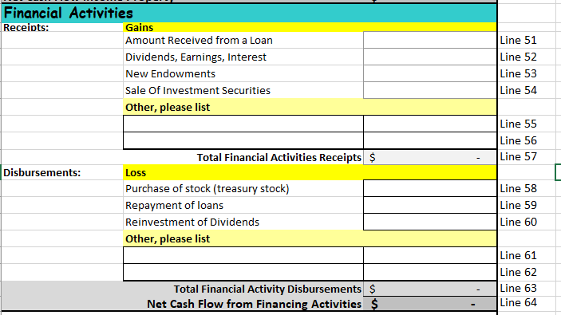
Receipts: Gains
- Line 51 – Amount Received from a Loan
  - Enter the total amount of any loans received
- Line 52 - Dividends, Earnings, Interest
  - Enter the total amount of any dividends, earnings, or interest received from all investments
- Line 53 - New Endowments
  - Enter the total amount of any new endowments received
- Line 54 - Sale Of Investment Securities
  - Enter the income received as a result of the sale of stocks, bonds, or other investment securities
- Other, please list
  - Line 55 - enter a brief description and a dollar amount for any financial income not otherwise recorded
  - Line 56 - same as Line 55 (if needed)
- Line 57 - Total Financing Activities Receipts
  - For Excel – this is auto calculated
  - For manual processing
    - Add Lines 51 through 56 and enter the sum here
- Line 58 - Purchase of stock (treasury stock)
  - Enter the total amount expended for the purchase of stocks, bonds, or other financial instruments
- Line 59 - Repayment of loans
  - Enter the total amount repaid in loans, but do not include mortgage or property loans which are included elsewhere in this form
- Line 60 - Reinvestment of Dividends
  - Enter the total amount of dividends reinvested
- Other, please list
  - Line 61 - enter a brief description and a dollar amount for any financial expense not otherwise recorded
  - Line 62 - same as Line 61 (if needed)
- Line 63 - Total Financing Activity Disbursements
  - For Excel – this is auto calculated
  - For manual processing
    - Add Lines 58 through 62 and enter the sum here
- Line 64 - Net Cash Flow from Financing Activities
  - For Excel – this is auto calculated
  - For manual processing
    - Subtract Line 63 (Total Financing Activity Disbursements) from Line 57 (Total Financing Activities Receipts) and enter the difference here
TOTALS
This section shows the totals for the report.
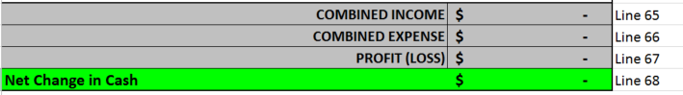
Line 65 - COMBINED INCOME
- For Excel – this is auto calculated
- For manual processing
  - Add Line 20 (Total Operating receipts), Line 39 (Total Property receipts), and Line 57 (Total Financial Activities Receipts) and enter the sum here

Line 66 - COMBINED EXPENSE
- For Excel – this is auto calculated
- For manual processing
  - Add Line 33 (Total Operating Disbursements), Line 49 (Total Property Disbursements), and Line 63 and enter the sum here
Line 67 - PROFIT (LOSS)
  - For Excel – this is auto calculated
  - For manual processing
    - Subtract Line 66 (COMBINED EXPENSE) from Line 65 (COMBINED INCOME) and enter the difference here

Line 68 – Net Change in Cash
  - This is a double check field which should be equal to Line 67 (PROFIT (LOSS)); it is calculated differently than Line 67, but the two numbers should be equal.
  - For Excel – this is auto calculated
  - For manual processing
    - Add Line 34 (Net Cash Flow from Operations), Line 50 (Net Cash Flow Income Property), and Line 64 (Net Cash Flow from Financing Activities)
Cash at End of Year
This section records the assets that the parish has at the end of the recording period.
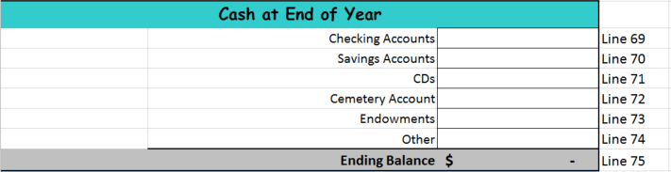
- Line 69 - Checking Accounts
  - Enter the total amount in all parish checking accounts at the end of the reporting period
- Line 70 - Savings Accounts
  - Enter the total amount in all parish savings accounts at the end of the reporting period
- Line 71 - CDs
  - Enter the current value of all Certificates of Deposit owned by the church at the end of the reporting period
- Line 72 - Cemetery Account
  - If the parish has a cemetery and maintains separate accounts for the cemetery then enter the amount in all cemetery accounts at the end of the reporting period
- Line 73 – Endowments
  - If there are any restricted endowments in accounts separate from your checking or savings account enter the total amount at the end of the reporting period here
- Line 74 – Other
  - If the parish is holding non-cash assets, such as stocks, savings bonds, or other liquid assets then enter the total amount at the end of the reporting period here
    - Do not enter the value of real estate, autos, personal property, etc
- Line 75 - Ending Balance
  - For Excel – this is auto calculated
    - There is an automatic crosscheck area at the bottom of the spreadsheet that ensures that the Ending Balance equals the Beginning Balance (Line 14) + the Net Change in Cash (Line 68)
    - If the numbers entered match the following will appear:
- If the numbers don’t match the following will appear:
  - Should this occur validate the entries you have made, particularly the beginning and ending balances
  - Note: Crosscheck may fail if rounding is used or if reports run on an accrual basis are used for numbers entered. Small differences can be ignored and the report submitted with a crosscheck failure.
  - For manual processing
    - Add Lines 69 through 74 and enter the sum here
    - Manually calculate to ensure that the Ending Balance equals the Beginning Balance (Line 14) + the Net Change in Cash (Line 68)
  - If the numbers do not match validate the entries you have made, particularly the beginning and ending balances
  - Note: Crosscheck may fail if rounding is used or if reports run on an accrual basis are used for numbers entered. Small differences can be ignored and the report submitted with a crosscheck failure.

Year numbers in examples are 20xx where xx represents the first year represented in the report, and 20xy represents the next year (20xx+1).

